VGG or more formally known as Visual Geometry Group is a subclass of CNN. The VGG is proposed by the Visual Geometry Group from the University of Oxford. VGGs are characterized by their simplicity and depth compared to conventional CNNs. Utilizing multiple small (3x3) convolutional layers, forming very deep networks (11-19 weighted layers). The configurations of the different VGG models described in the original paper are as follows:

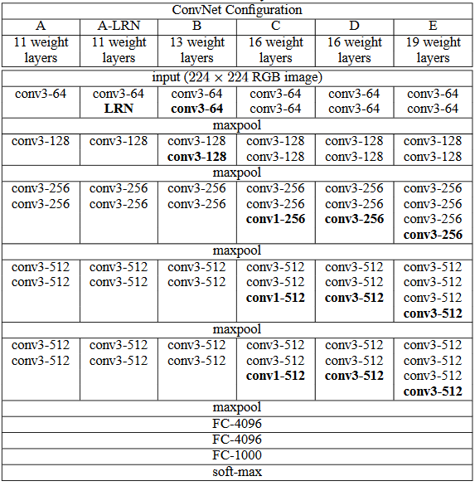

Some characteristics of VGG models:

* Uses only small 3 x3 convolutional layers
* All layers use the same convolutional filter and pooling size
* Large number of layers VGG-11 and VGG-19 (all fully connected or convolutional)
* Max pooling: 2x2 filter with stride of 2
* Excels at image classification
* Often used for image classification and transfer learning
* Pros : Simple to understand and implement
* Cons: Large computational resources required to train and tune

Since, there has been several variations:

* Tiny VGG : smaller version, designed for efficiency and lower computational power
* VGG with batch normalization
* VGGs with different activation functions
* Dilated VGG: using dilated/atrous convolution(
* etc

Sources:

Original paper: <https://arxiv.org/pdf/1409.1556>